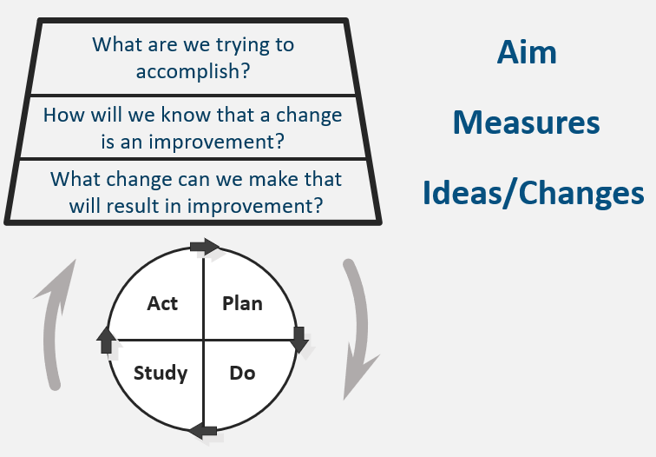
Use this template tool to plan and document your progress with each test of change conducted. Answer the first two questions below. Then as you plan to test changes to meet your aim, answer question 3 below and plan, conduct, and document your PDSA cycles. Small tests of change will usually involve multiple PDSA cycles in order to achieve your aim. Use as many forms as you need to track your PDSA cycles.

PDSA Cycle Template
- What are we trying to accomplish (Aim)?
What is your aim statement?

- How will we know that a change is an improvement (measures)?
Describe measurable outcomes you want to see.

- What change can we make that will result in an improvement? Define
Define current process or state. Look for causes of problems that have occurred; where do breakdowns occur, have “work-a-rounds” been developed, are there duplicate or unnecessary steps? Determine what you will change in the process; determine your intervention based on analysis. Are there better ways to do things, what are the root causes, what has worked for other organizations? The solution doesn’t have to be perfect the first time.

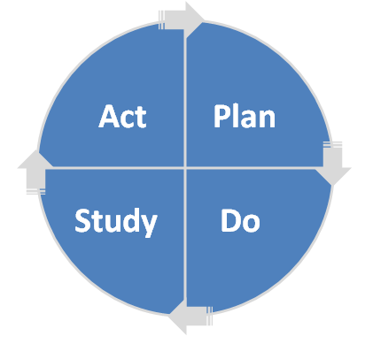
PLAN | What exactly are we going to do?  What change are we testing with the PDSA cycle(s)? What do we predict will happen and why? Who will be involved in this PDSA? (e.g., one staff member or client, next 2 inquiries?). Whenever feasible, it will be helpful to involve direct care staff. Plan a small test of change. How long will the change take to implement? What resources will they need? What data need to be collected? | List the action steps, names of those responsible and timeline.
DO | When and how did we do it?  Carry out the test on a small scale. Document observations, including any problems and unexpected findings. Collect data you identified as needed during the “plan” stage. | Describe what actually happened when you ran the test.
STUDY | What were the results?  Study and analyze the data. Determine if the change resulted in the expected outcome. Were there implementation lessons? Summarize what was learned. Look for: unintended consequences, surprises, successes, failures. | Describe the measured results and how they compared to the predictions.
ACT | What changes are we going to make based on our findings?  Based on what was learned from the test: Adapt – modify the changes and repeat PDSA cycle. Adopt – consider expanding the changes in your organization to additional residents, staff, and units. Abandon – change your approach and repeat PDSA cycle. | Describe what modifications to the plan will be made for the next cycle from what you learned.

